Dale Smallwood 130089872

Critically review – Task 5

Contents

Table of Figures 2

Introduction 3

Design phase 4

Theme 4

Layout 4

Responsiveness 4

Cross-browser testing 5

Internet Explorer 5

Microsoft Edge 6

Google Chrome 7

7

Summary 7

References 8

# Table of Figures

Figure 1 - Internet Explorer 5

Figure 2 - Microsoft Edge 6

Figure 3 - Google Chrome 7

# Introduction

Inside this document is an analysis of the website named Wicked Inventions, comparing the specifications requested to the final product and extra added features that may improve usability.

# Design phase

After overlooking the wireframe and comparing there are quite a lot of alterations to the final design for instance the wireframe contains a breadcrumb trail, but the finished product does not this may be because it was overlooked, on the other hand, the finished product contains the required parameters such as the uses of the plumb purple and neon green colours as well as this there are more than six pages.

## Theme

The theme of the website has matched the requirements presented by the client as it contains colours plumb purple, and neon green and uses a flower power-related background image the font is also displayed in Tahoma although these are the set requirements, they do not look very appealing so an enquiry with the client may be needed to come up with a solution.

## Layout

After navigating the website smoothly with the drop-down feature it has come to my attention that there is an excellent use of white spacing keeping the user intrigued and preventing them from losing interest, alongside this there are videos related to the subject that is easily accessible, on the contact page there are the two requested links provided (Facebook and Pinterest) both of these links are easily accessible by simply clicking the icon provided these are displayed bellow an interactive map of the clients desired location.

## Responsiveness

While Viewing each page on multiple scale sizes the majority of the features scale down correctly, but it has come to my attention that the background image for the website does not cover the entire background when displayed on a mobile device although this is a bug it is only a minor issue as it doesn’t impact usage of the website, alongside this surprisingly the dropdown menu was also scaled down correctly and functions with ease.

## Cross-browser testing

The display of the website is altered drastically when using older browsers such as internet explorer as a lot of features are not available in this section figures are showing how the home page is displayed on each browser provided.

### Internet Explorer

As shown in (fig1) the home page is drastically altered and looks unprofessional, but this happens because internet explorer lacks many features and has become outdated over the years, according to (Warren, 2020) “Microsoft will end support for Internet Explorer 11 on August 17th, 2021” therefor this current issue will be resolved.

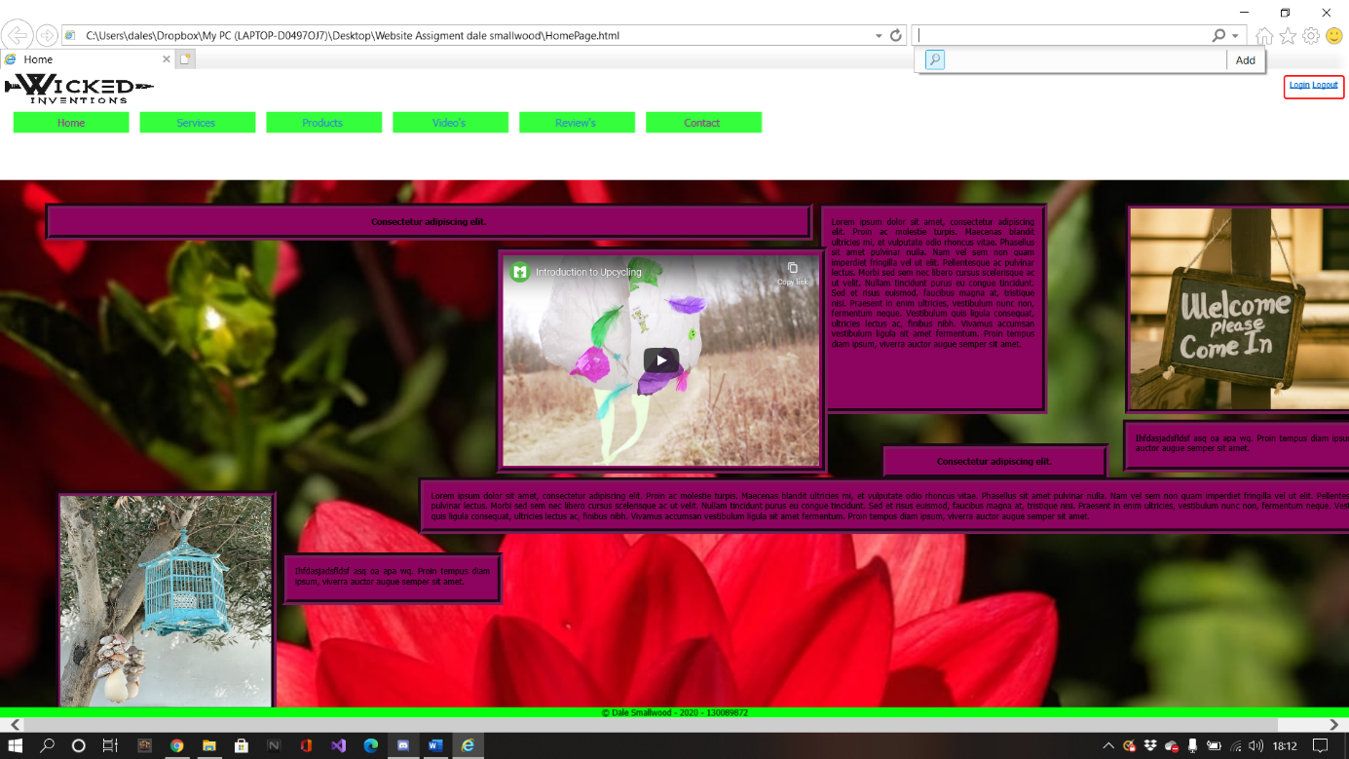

Figure - Internet explorer

### Microsoft Edge

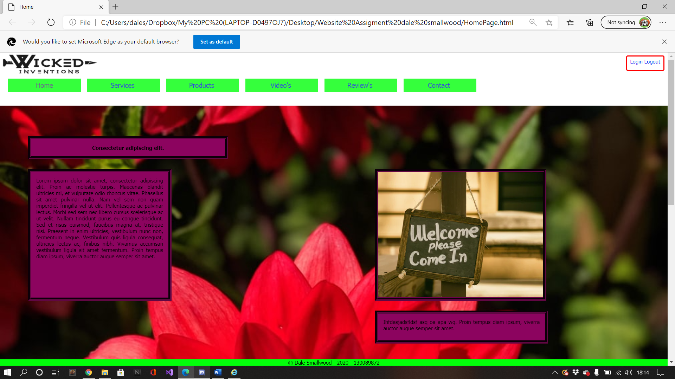As shown in (fig2) the home page when displayed on the Microsoft Edge browser the layout is displayed correctly as intended this is because the features used to style this web page are available on Microsoft Edge, the reason this browser was selected to be tested is that Microsoft edge can be obtained from default factory settings meaning this might be used very frequently.

Figure - Microsoft edge

### Google Chrome

As shown in (fig3) the layout is identical to Microsoft Edge other than the URL UI, the reason this browser was selected is Google Chrome is one of the most recognized and most popular browsers used in the last 5 years this is supported by (The Nation Thailand : News Desk : Asia News Network, 2017) “62.09% of web surfers use Chrome”.

### 

Figure - Google chrome

## Summary

In conclusion, although the design of the website design could be improved the set requirements have been met and is easily accessible for users to navigate alongside this it also contains relevant information in different formats such as video, images and text, But lacks ease of access for impaired users this feature could be implemented at a later date if brought to attention as well as this the design does not follow the sitemap and wireframe early design but this may be an improvement.

# References

The Nation Thailand: News Desk: Asia News Network. (2017, October 5th). *News: International*. Retrieved January 6th, 2012, from Google Chrome remains the most popular browser in the world: https://www.nationthailand.com/news/30328504

Warren, T. (2020, August 17th). *Tech: Microsoft*. (TheVerge) Retrieved January 6th, 2021, from Microsoft will bid farewell to Internet Explorer and legacy Edge in 2021: https://www.theverge.com/2020/8/17/21372487/microsoft-internet-explorer-11-support-end-365-legacy-edge